Liam King and Brandon Patton

Individual Deliverable 1

We divided into further sub-groups within our sub-group. We both found the following:

We are working on figuring out how to visualize the data in an effective way. As a group, we decided that plotting the information would be most effective using R. To do this, we had to look into R and figure out how to use the language to accomplish our tasks. This is a screenshot of plotted data in R.

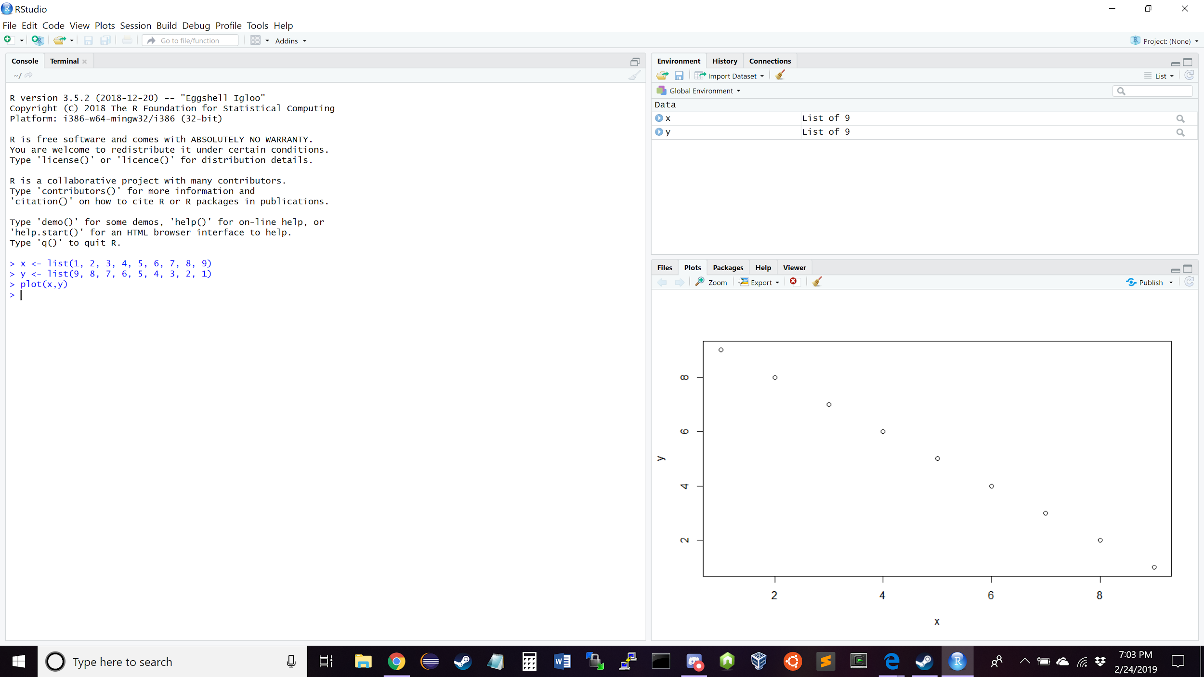

We also wanted to plot a line of best fit in addition to plotting the data. This is a screenshot of a line of best fit plotted with other data points.

